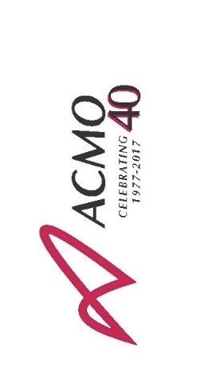
Call for Presenters

Name:
Company:
Address:
Phone:
Email:

Are you available on Wednesday, June 14 for the video shoot at the production studio in the GTA?
Please identify your area(s) of expertise:
- Roof Repairs
- Roof Maintenance
- Elevator maintenance
- Elevators: working with the TSSA
- Health & Safety for major refurbishment project
- Financing a major refurbishment project
- Energy retrofits
- Best practices for property managers / staff working with multiple contractors
- Insurance claims procedures
- LEED certification: achieving certification
- LEED certification: managing / maintaining certification
- Garage projects
- Basement flooding
Do you have visuals that could be used in the videos (e.g. slides, graphics, video clips)? Please describe:

Please submit this completed form along with your 500-word synopsis to Kristy Joplin at kjoplin@acmo.org by no later than 5:00 p.m. on May 17, 2017.

